RED LION YOUTH FLAG FOOTBALL Age 14-15 Division * “THINK POSITIVE * BE POSITIVE”

* ALL PLAYERS MUST PLAY AT LEAST 50% OF EACH GAME
“Romans 10:9”
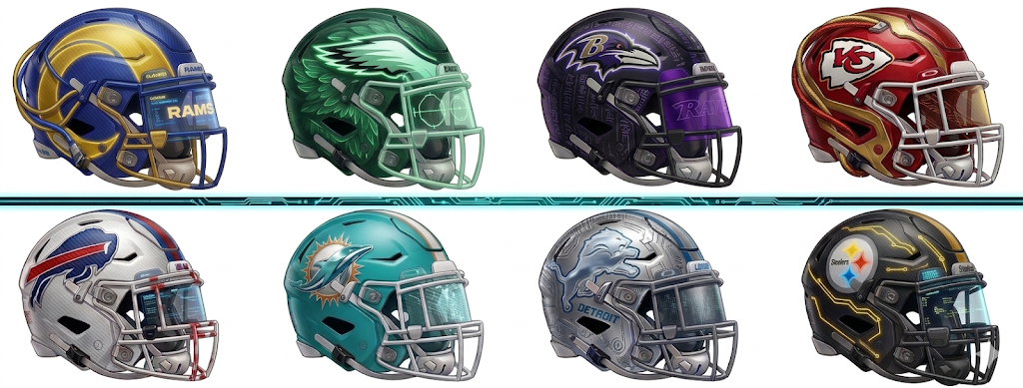
Age 14-15 Division
Week 1 * Arrive 1 hour prior to your scheduled time for practice
Date Time Home Team Away Team Field
- Sun 3/29/2026 6:00 pm Eagles Dolphins Field 1
- Sun 3/29/2026 6:00 pm Ravens Steelers Field 2
- Sun 3/29/2026 6:00 pm Lions Rams Field 3
- Sun 3/29/2026 6:00 pm Bills Chiefs Field 5

4/5/26 WE are off on Easter Sunday * Happy Easter and Resurrection DAY!
We wish you and your families a very Happy Easter and a meaningful Resurrection Day. We look forward to seeing everyone back and energized next week!


RED LION YOUTH FLAG FOOTBALL Age 14-15 Division * “THINK POSITIVE * BE POSITIVE”
* ALL PLAYERS MUST PLAY AT LEAST 50% OF EACH GAME
“Romans 10:9”

Week 2 * Arrive 1 hour prior to your scheduled time for practice
- Sun 4/12/2026 6:00 pm Lions Ravens Field 1
- Sun 4/12/2026 6:00 pm Bills Steelers Field 2
- Sun 4/12/2026 6:00 pm Dolphins Rams Field 3
- Sun 4/12/2026 6:00 pm Chiefs Eagles Field 5

Week 3* Arrive 1 hour prior to your scheduled time for practice
- Sun 4/19/2026 6:00 pm Ravens Bills Field 1
- Sun 4/19/2026 6:00 pm Chiefs Dolphins Field 2
- Sun 4/19/2026 6:00 pm Steelers Rams Field 3
- Sun 4/19/2026 6:00 pm Eagles Lions Field 5

Week 4 * Arrive 1 hour prior to your scheduled time for practice
- Sun 4/26/2026 6:00 pm Chiefs Lions Field 1
- Sun 4/26/2026 6:00 pm Eagles Steelers Field 2
- Sun 4/26/2026 6:00 pm Bills Dolphins Field 3
- Sun 4/26/2026 6:00 pm Ravens Rams Field 5

Week 5* Arrive 1 hour prior to your scheduled time for practice
- Sun 5/3/2026 6:00 pm Eagles Rams Field 1
- Sun 5/3/2026 6:00 pm Ravens Chiefs Field 2
- Sun 5/3/2026 6:00 pm Bills Lions Field 3
- Sun 5/3/2026 6:00 pm Dolphins Steelers Field 5

RED LION YOUTH FLAG FOOTBALL Age 14-15 Division * “THINK POSITIVE * BE POSITIVE”
* ALL PLAYERS MUST PLAY AT LEAST 50% OF EACH GAME
“Romans 10:9”


*WE ARE OFF ON 5/10/26 HAPPY MOTHER’S DAY! HOPE ALL OF OUR MOM’s HAVE THE BEST DAY EVER!
We want to take this opportunity to wish all of our mothers and grandmothers a very Happy Mother’s Day! We hope you have a wonderful day of celebration and relaxation with your families!

Week 6* Arrive 1 hour prior to your scheduled time for practice
- Sun 5/17/2026 6:00 pm Chiefs Steelers Field 1
- Sun 5/17/2026 6:00 pm Ravens Eagles Field 2
- Sun 5/17/2026 6:00 pm Rams Bills Field 3
- Sun 5/17/2026 6:00 pm Lions Dolphins Field 5

WE ARE OFF MEMORIAL DAY WEEKEND (May 24th) as we honor and remember those who served!

RED LION YOUTH FLAG FOOTBALL Age 14-15 Division * “THINK POSITIVE * BE POSITIVE”
* ALL PLAYERS MUST PLAY AT LEAST 50% OF EACH GAME
“Romans 10:9”

Week 7 * Playoffs* Arrive 1 hour prior to your scheduled time for practice –
ALL TEAMS ADVANCE TO 6/7/26 CHAMPIONSHIIP SUNDAY AND AWARDS!

- Sun 5/31/2026 6:00 pm Seed 1 Seed 4 Field 1
- Sun 5/31/2026 6:00 pm Seed 2 Seed 3 Field 2
- Sun 5/31/2026 6:00 pm Seed 5 Seed 8 Field 3
- Sun 5/31/2026 6:00 pm Seed 6 Seed 7 Field 5

Week 8 - Final Week - Superbowl * Championships and Awards ( All teams play on this day. All to be determined)
D1 Bracket – Semi Finals
- Sun 6/7/2026- Superbowl 12:45 pm Winner of game # 25 vs. Winner of game #26 Field 1

- Sun 6/7/2026 D1 Championship Games 25/26 12:45 pm vs. Field 2
D2 Bracket - Championships
- Sun 6/7/2026 12:45 pm Blue Gold Championship: Winners from Game 27 and 28 Field 3
- Sun 6/7/2026 12:45 pm Diamond State Championship 2 remaining non advancing seeds Field 5

THANK YOU FOR BEING A PART OF OUR LEAGUE!
May God bless you and your family!

